7.84: a)
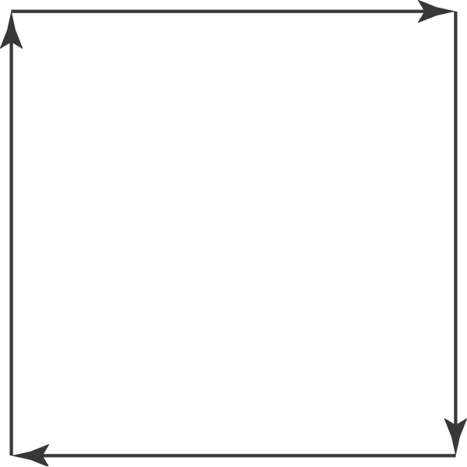

b) (1):  along this leg, so 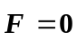 and 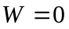. (2): Along this leg, 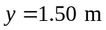, so 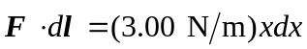, and (3) 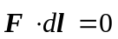, so (4) 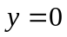, so 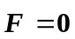 and . The work done in moving around the closed path is 3.38 J. c) The work done in moving around a closed path is not zero, and the force is not conservative.

